**MDF Rose Engine Lathe 2.0**

**with Stepper Motor Drive**

**Instructions for Building**

**Jigs, Fixtures, & Add-Ons**

**Version 0.1**

**05 February 2021**

This document is intended to help one familiar with the MDF rose engine to easily build the identified jigs, fixtures, and add-ons. You can purchase these from us at [www.ColvinTools.com](http://www.ColvinTools.com), or build them yourself.

As you get started with building these jigs, fixtures, or add-ons to the MDF rose engine lathe, please consider making the machine exactly according to the outlined instructions. There are lots of ways you can modify this, and, quite frankly, the MDF rose engine encourages experimentation. But it is best to attempt those modifications after understanding how it works. Some ideas which sound grand may not appear so after understanding how the machine works (we speak from experience).

If you have any questions on the terminology in this document, check out the “Ornamental Turning Book of Knowledge” ([www.OTBoK.info](https://www.otbok.info/)).

Throughout this document, I’ve tried to show the MDF in its native color of tan/brown. There are differences in the images I captured from the CAD drawing made, but those are not representative of the machine’s differences.

The added pieces are typically shown in different colors to ensure they stand out from the MDF rose engine lathe.

Unless otherwise noted, the MDF is ¾” thick.

If you have any questions, please contact us at [ColvinTools@Gmail.com](mailto:ColvinTools@Gmail.com).

Good luck and we hope you enjoy this machine as much as we.

Rich Colvin & Jack Zimmel

Permission is not granted to manufacture these for sale.

Table of Contents

Amplitude Adjuster 4

Bill of Materials 4

Parts Details 5

# Amplitude Adjuster

**AA Rubber**

**AA Lever Arm**

**AA Spacer Block**

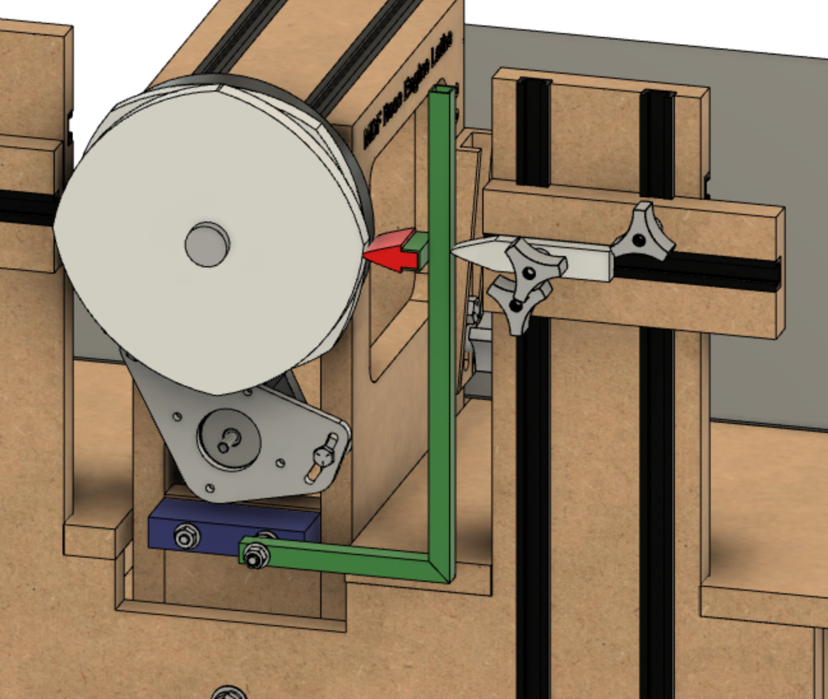

RS1

This amplitude adjuster (AA) consists of 3 pieces (plus attachment screws).

As installed, note how the **RS1** piece has been flipped around to open up space between the front rubber support column and the headstock. The MDF rose engine lathe 2.0 was designed to accommodate this.

## Bill of Materials

Materials required for building this are below. The item numbers are shown in the following drawings using an orange, circled number like the one to the right

| Item # | Item | Qty | Source | Source  Part Number | Comments |
| --- | --- | --- | --- | --- | --- |
| 1 | ½” square steel pipe |  |  |  | 24” long piece is plenty |
| 2 | ¾” MDF |  |  |  | 4” x 2” block is plenty |
| 3 | 1” thick HDPE |  |  |  | 2” x 2” block is plenty |
| 100 | ¼”-20 carriage bolt, 3 ½” long | 1 | Hardware store |  | A 4 ½” long bolt is recommended for use later on the double AA. |
| 101 | ¼”-20 carriage bolt, 2 ½” long | 1 | Hardware store |  |  |
| 102 | ¼”-20 hex nut | 2 | Hardware store |  |  |
| 103 | ¼”-20 hex lock nut | 1 | Hardware store |  |  |
| 104 | ¼” washer | 4 | Hardware store |  |  |

## Parts Details

Details on the making of these parts are below.

### AA Spacer Block

This is made from a piece of ¾” MDF. The block is used to space the lever arm the correct distance from the headstock.

The holes for the bolts are drilled ¾” from either side.

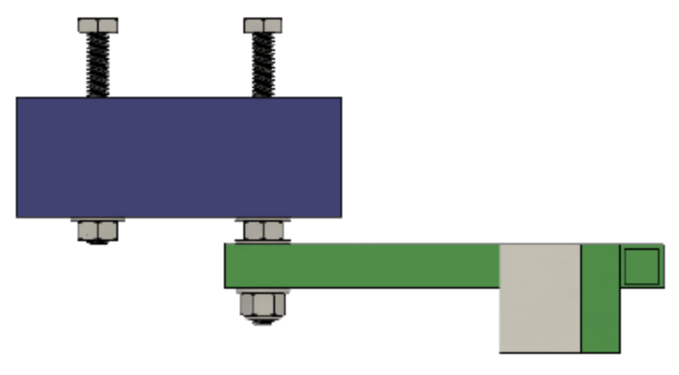

**1 3/8”**

**3 3/4”**

**3/4”**

**3/4”**

**Top View**

The holes are drilled with an “F” drill (0.257”). A 17/64” (0.2656”) can be used if you don’t have letter drills.

These pictures below show how the MDF Spacer Block is attached to the headstock (**H2** is removed for visual clarity).

It is attached by bolts to the **H4L** piece.

* The bolt on the right is a ¼”-20 TPI, 3 ½” long.
  + There is a hex nut between the AA lever arm and the AA spacer block. A washer is on either side of this nut.
  + There is a lock nut holding the AA lever arm in place. It is tightened enough to prevent too much side-to-side movement, but not so much that the lever action is restrained.
  + A flat washer is between the lock nut and the lever arm.
  + **NOTE:** A bolt that is 4 ½” long is recommended. This will give extra length that will be needed for the double-AA (that design to be added to this document later).
* The bolt on the right is a ¼”-20 TPI, 2 ½” long.
  + There is a hex nut and flat washer holding the AA spacer block in place.
  + This helps provide a rigid base for the lever action.
* The bolts shown here have a hex head; however, carriage bolts are recommended.

### AA Lever Arm

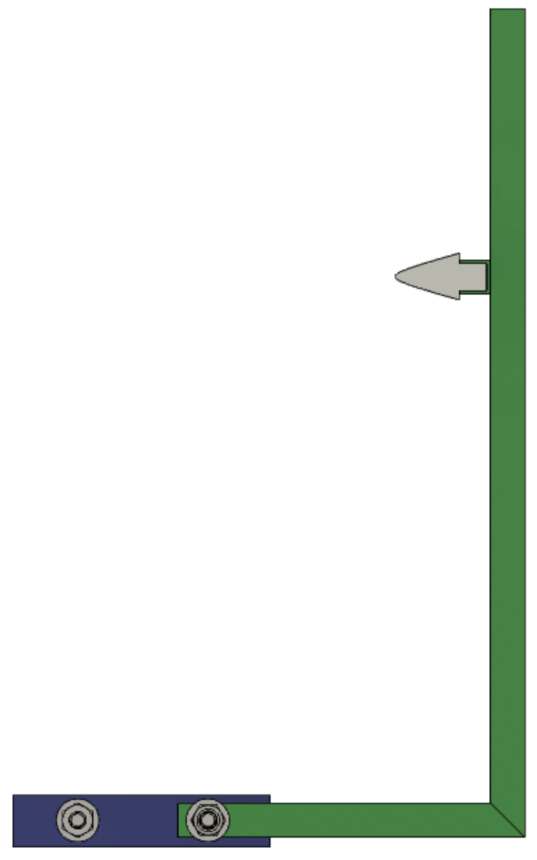

**12”**

**7 3/8”**

**5”**

**Side View**

(Rotated 90°)

The lever arm is what does the work of adjusting the amplitude.

There is a YouTube video showing it in action, so I won’t discuss its use here.

The hole for the ¼” retaining bolt is drilled ¾” from the end and is drilled with an “F” drill (0.257”). A 17/64” (0.2656”) can be used if you don’t have letter drills.

This is made from ½” square steel pipe.

The part of the lever arm which holds the AA rubber is made from the same ½” square pipe but has one side cut off to make it a channel. Be careful to not cut off too much as this channel is used to hold the   
AA rubber.

This needs to be 1 ¼” long.

The three pieces are welded together.

Paint it the color desired. Mine is painted black.

### AA Rubber

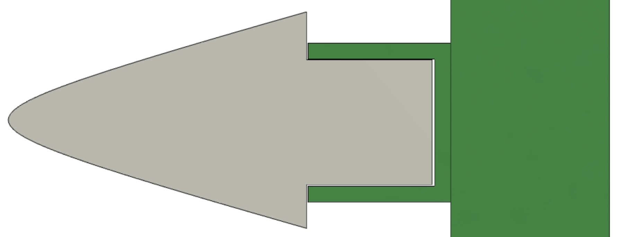

**1 3/8”**

**3/8”**

**3/8”**

**5/8” \***



**1 1/4”**

**Side View**

**Edge View**

This amplitude adjuster is designed to accommodate whatever shape of rubber the artist desires.

These may be made of HDPE plastic like the original ones, or other materials like wood could also be used.

The shape shown to the right mirrors the rubber shipped with the MDF rose engine lathe.

The only critical dimensions are:

* The part of the rubber which fits into the metal lever arm should be
  + 3/8” high and
  + 3/8” deep
* The overall width of the amplitude adjuster should be 1 1/4” wide to ensure it covers both rosettes.
* The overall length should be around 1 3/8”. If longer, it may not fit well between the rosette and the rubber support column.

Other rubber shapes that could be considered include these. Note, the height is certainly not 5/8” for all of these.

1 3/8”

1 3/8”

1 3/8”

|  |  |  |
| --- | --- | --- |
| “T” Block | Large Radius Curve | Bearings |

To the extent that material may appear to be infringed, we assert that such alleged infringement is permissible under fair use principles in U.S. copyright laws. If you believe material has been used in an unauthorized manner, please contact me at [ColvinTools@Gmail.com](mailto:ColvinTools@Gmail.com).

Permission is not granted to manufacture these for sale.